A project Report On

**Zomato App(Clone)**

Name: More Karuna Shivaji

Type of Project : Web Technology

Technology : HTML5, CSS3, BOOTSTRAP5 & JAVASCRIPT

Date Of Submission: 16-10-2024

**Table Of Contents:**

1. Introduction
2. Project Objectives
3. Technologies Used
4. Features
5. Implementation
6. User Interface Design
7. Testing
8. Future Improvements
9. Conclusion

## 1. Introduction

The Zomato Clone project is a web application inspired by the popular food discovery and delivery service, Zomato. It aims to provide users with an interface to explore restaurants, events, and localities while also offering features such as restaurant addition, user authentication, and app download options.

## 2. Project Objectives

* To create a user-friendly web interface for food discovery.
* To allow users to search for restaurants, cuisines, and dishes.
* To display curated collections of restaurants based on trends.
* To provide a responsive layout that works well on various devices.
* To implement features for app download sharing via email or phone.

## 3. Technologies

* **HTML5**: For structuring the content of the web application.
* **CSS3**: For styling and layout design, including Bootstrap for responsiveness.
* **JavaScript**: For interactive functionalities such as search and app download sharing.
* **Bootstrap**: A CSS framework for responsive design.
* **Font Awesome**: For icons used throughout the application.

## 4. Features

* **Search Functionality**: Users can search for restaurants, cuisines, or dishes.
* **Restaurant Cards**: Displaying various options for online ordering, dining, and live events.
* **Curated Collections**: Highlighting trending spots, special treats, and newly opened places.
* **Locality Badges**: Showcasing popular localities with the number of places available.
* **Contact Section**: Allowing users to share the app download link via email or phone.

## 5. Implementation

### Structure

The project is divided into several sections:

* **Navbar**: Provides navigation links to important pages.
* **Background Section**: Contains a hero image with a search bar.
* **Restaurant List**: Displays various restaurant options in card format.
* **Collections Section**: Highlights curated lists based on trends.
* **Locality Section**: Lists popular localities with badges.
* **Contact Section**: Allows users to request the app download link.

## 6. Output Screens

HOME

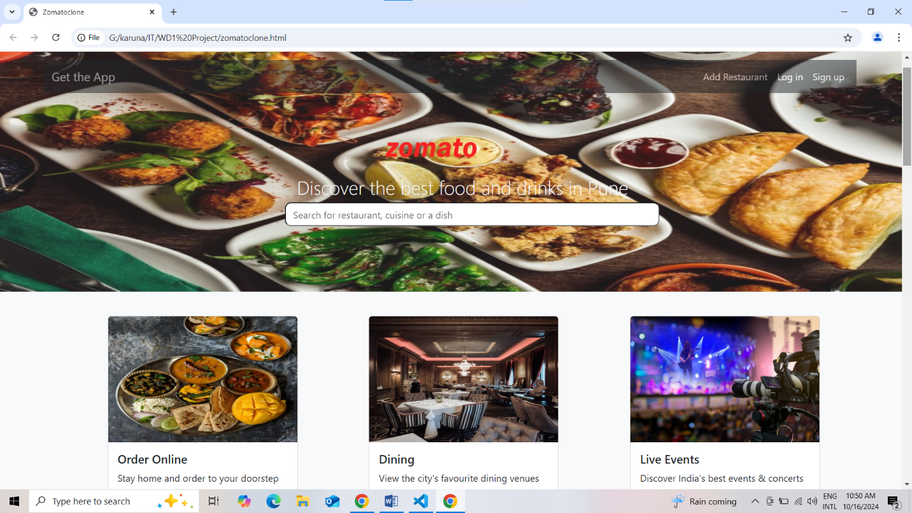

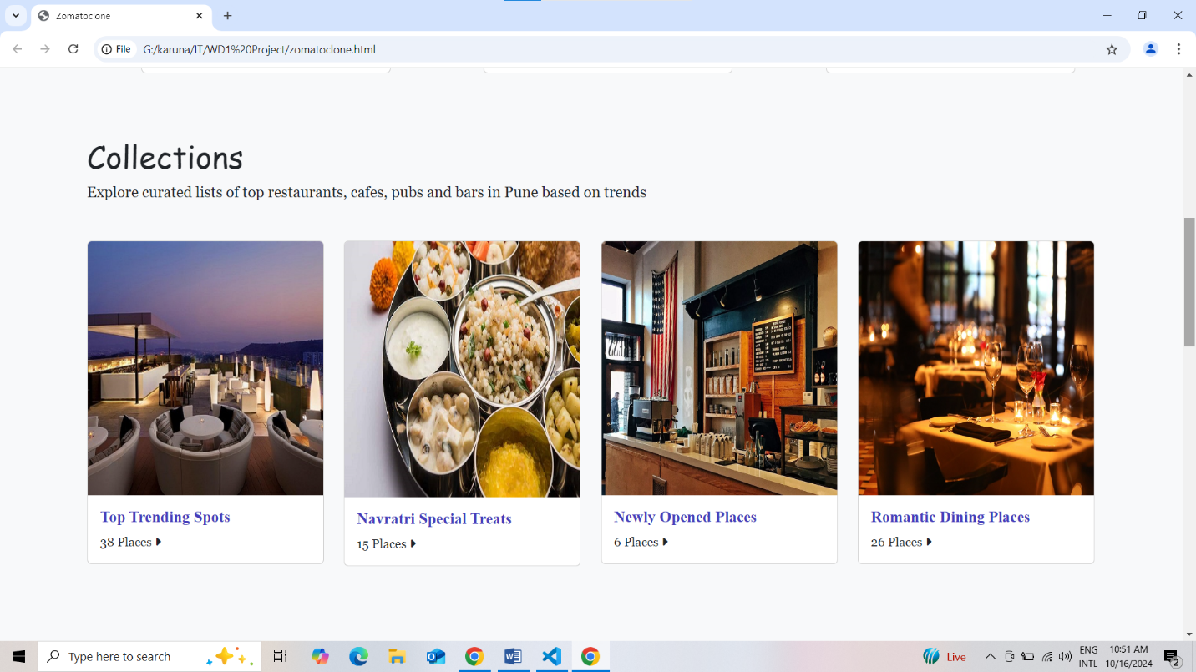

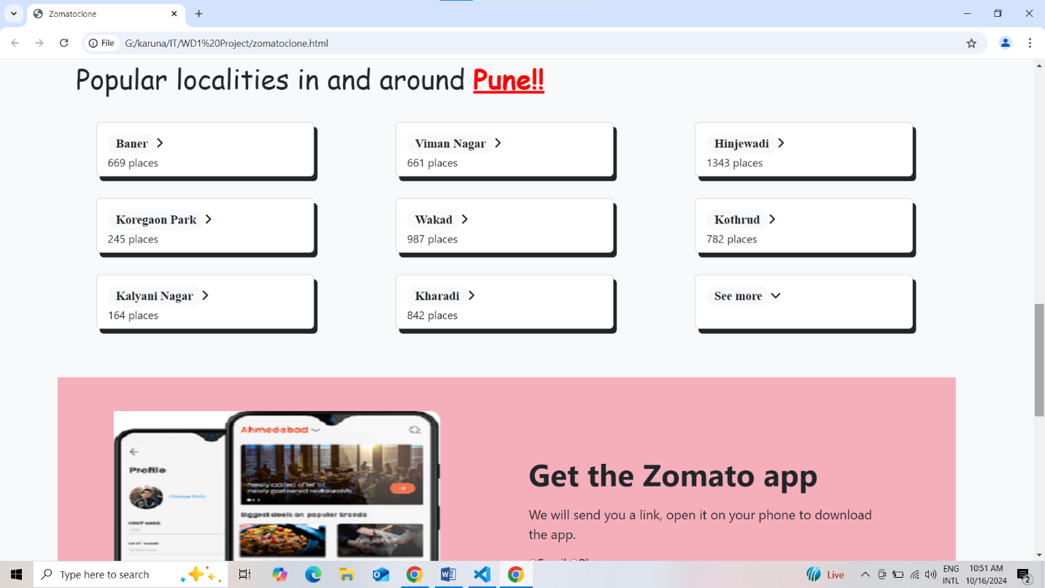

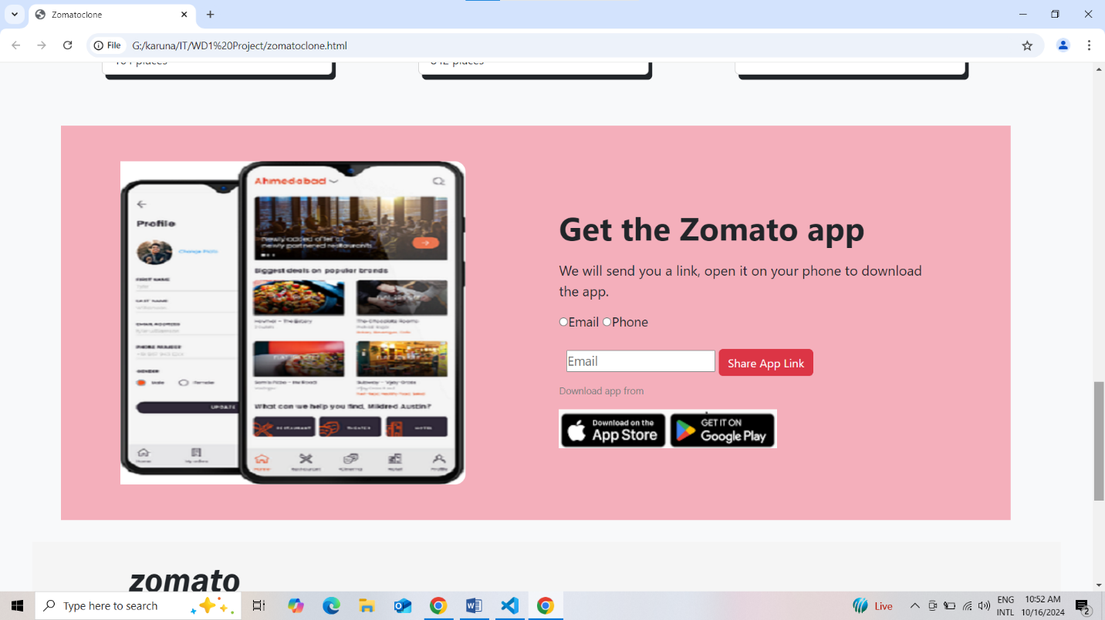

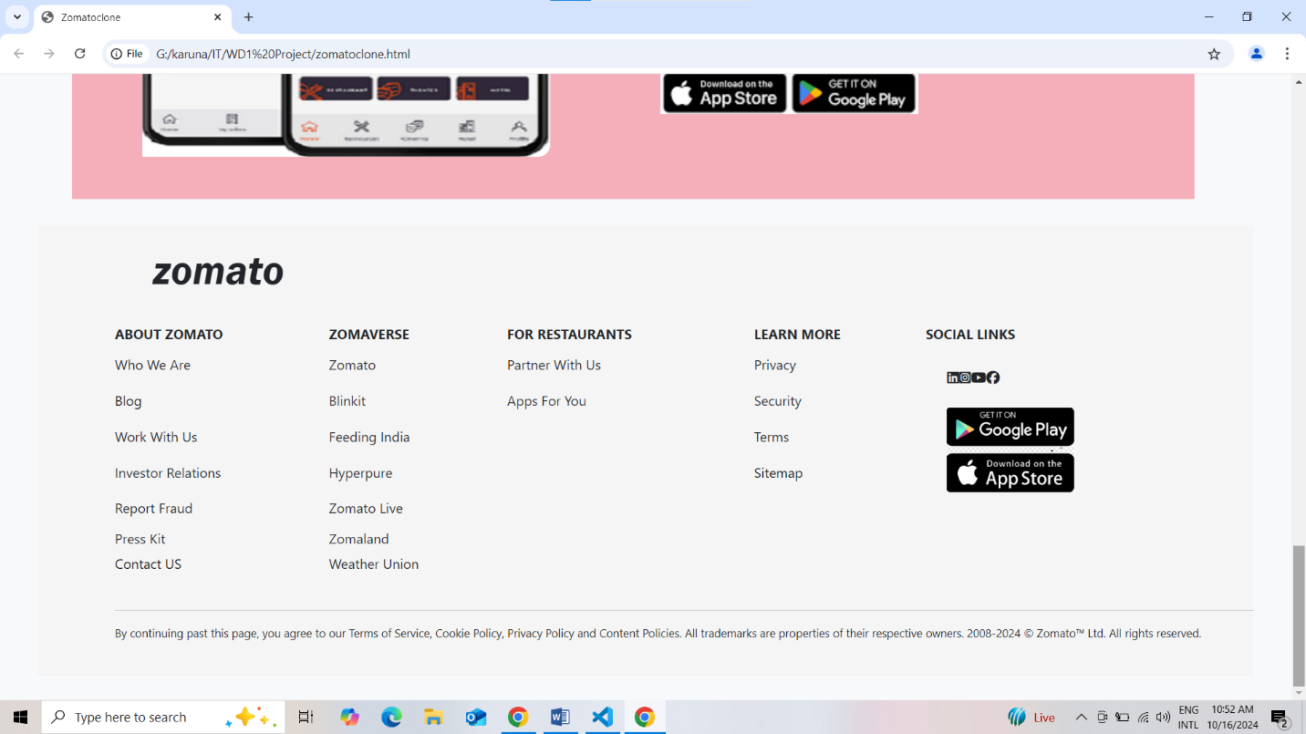

GET APP SECTION

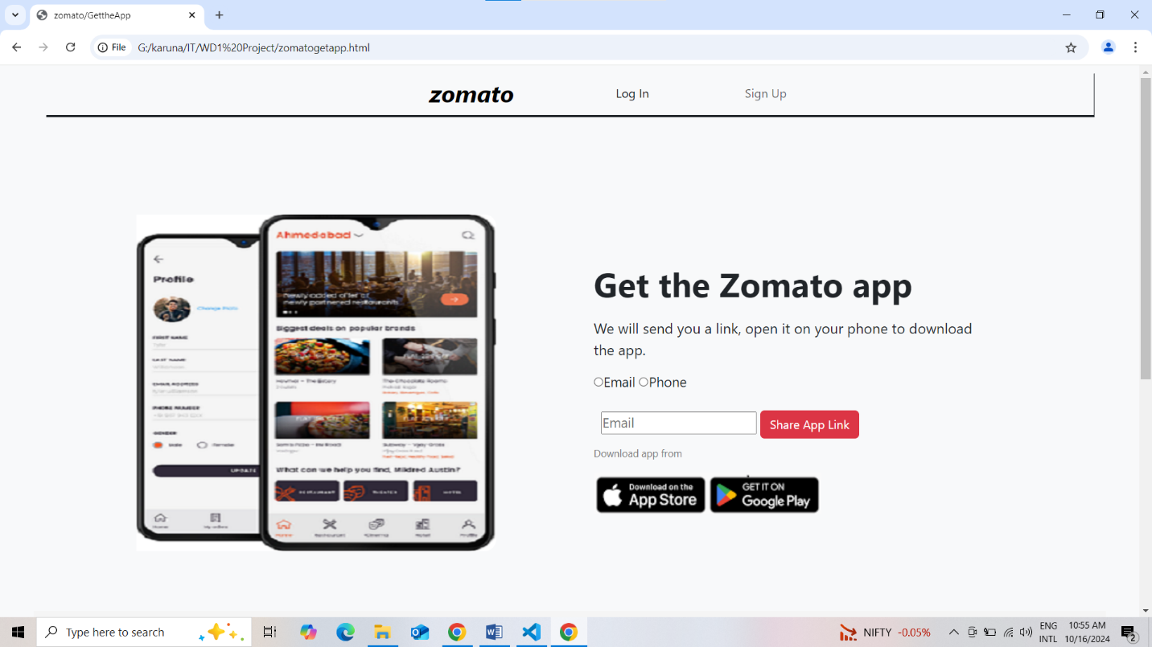

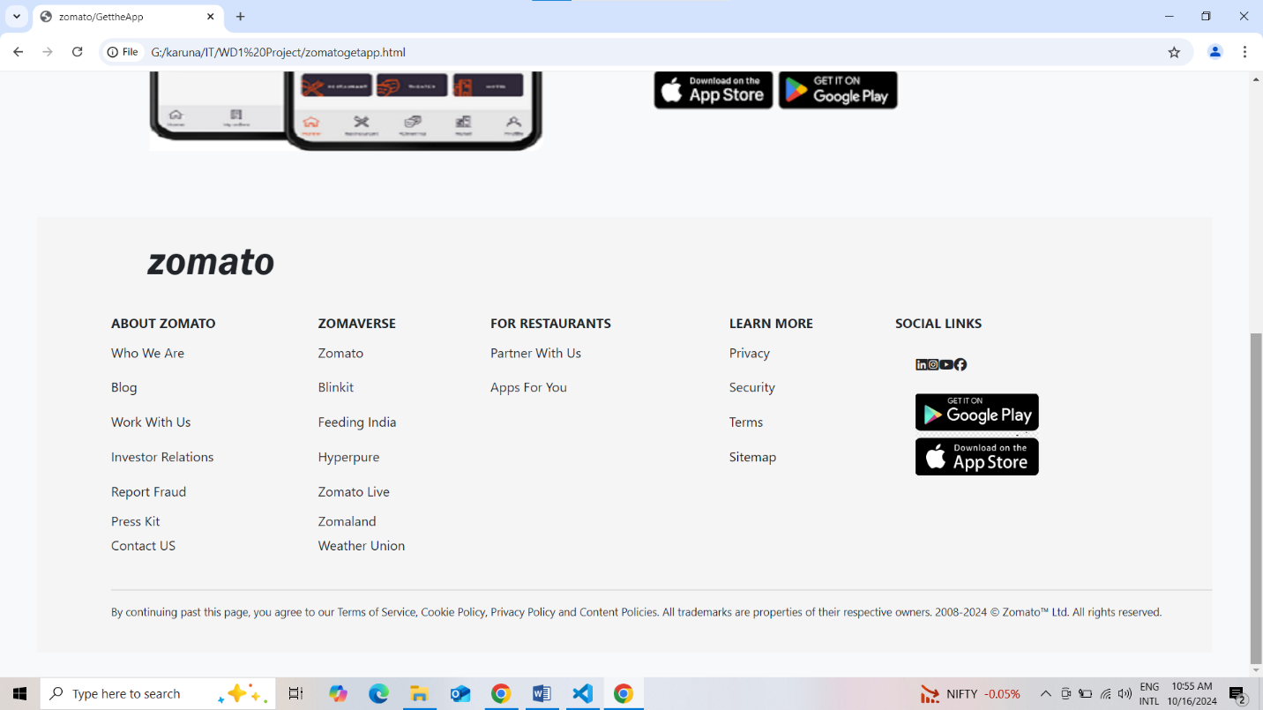

ADD RESTAURANT SECTION

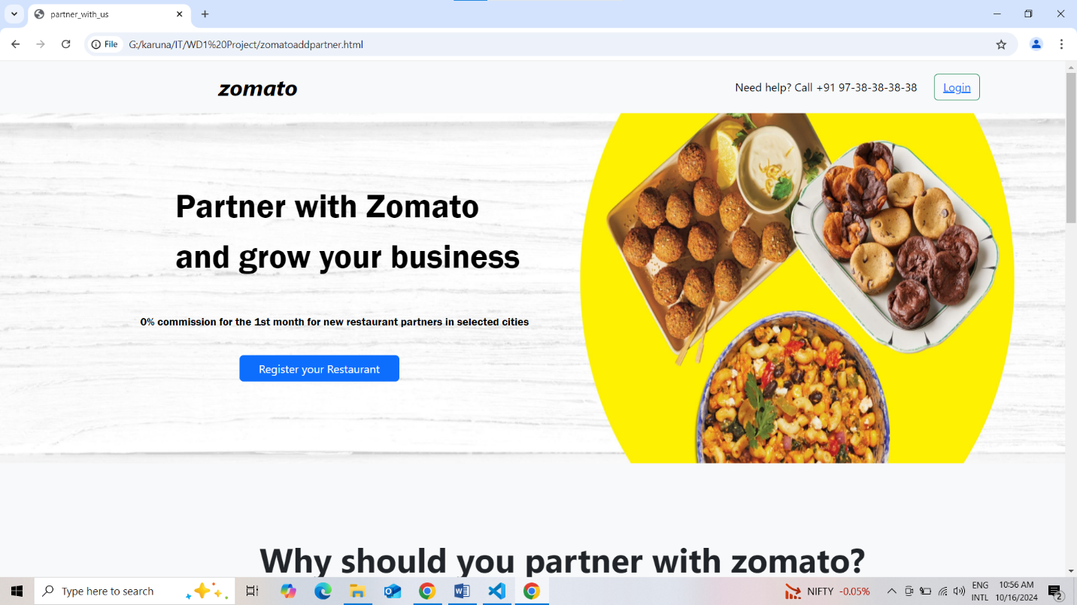

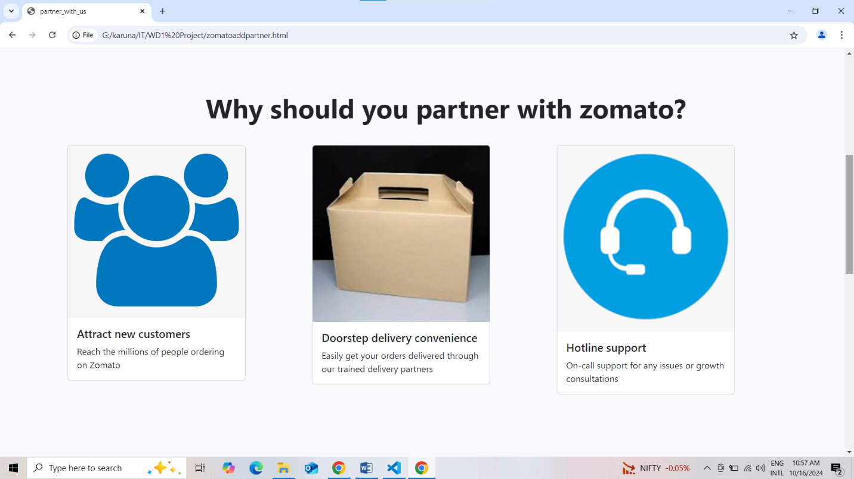

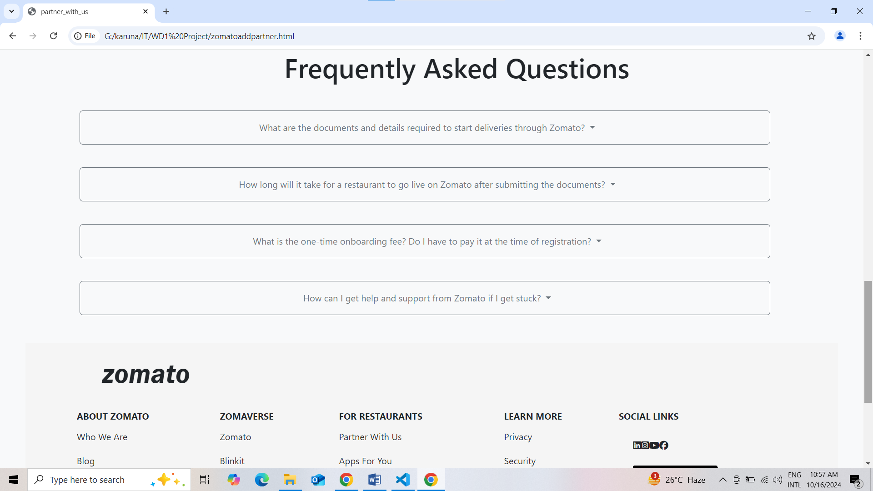

LOGIN PAGE

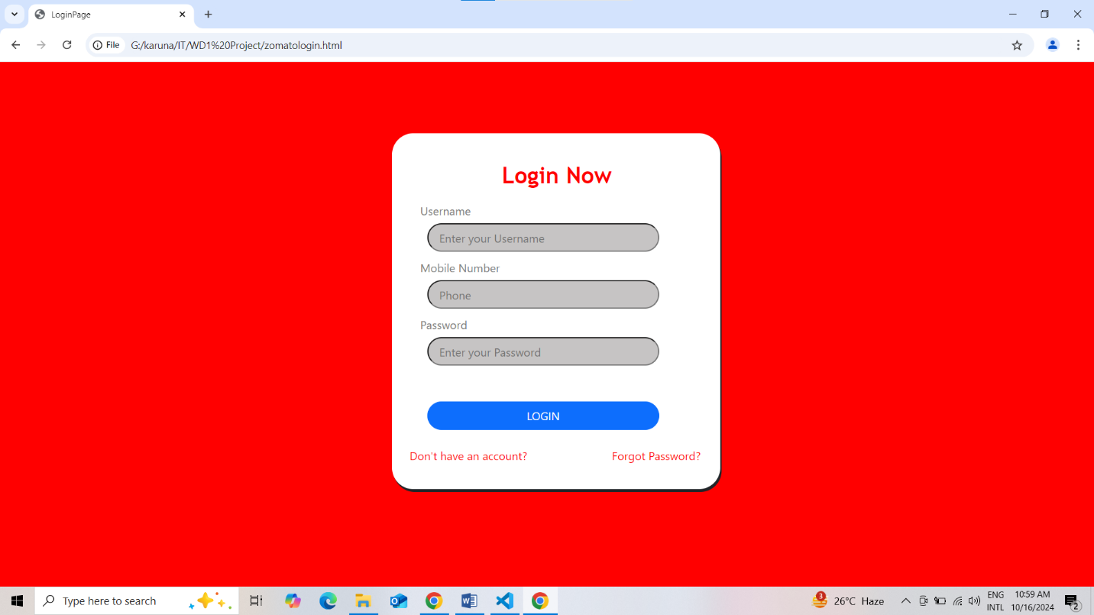

SIGN UP PAGE

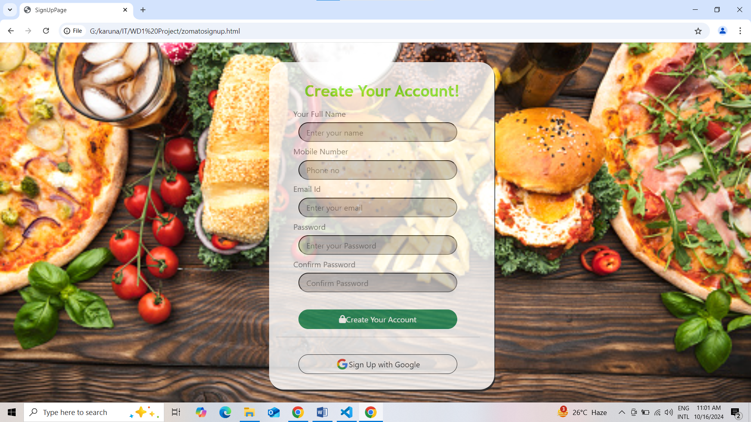

BLOG (FOOTER SECTION)

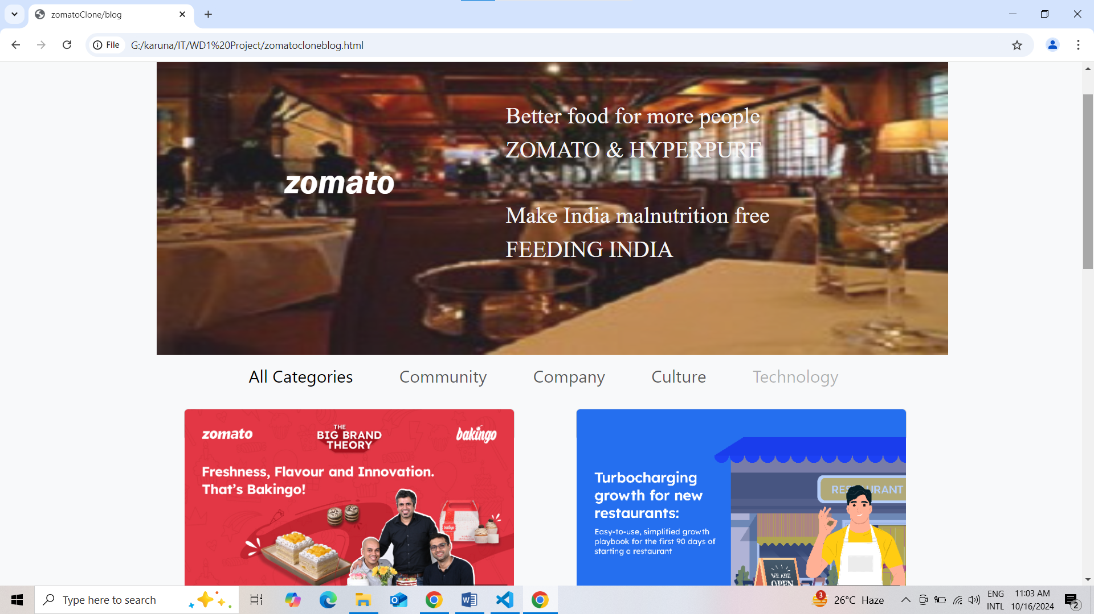

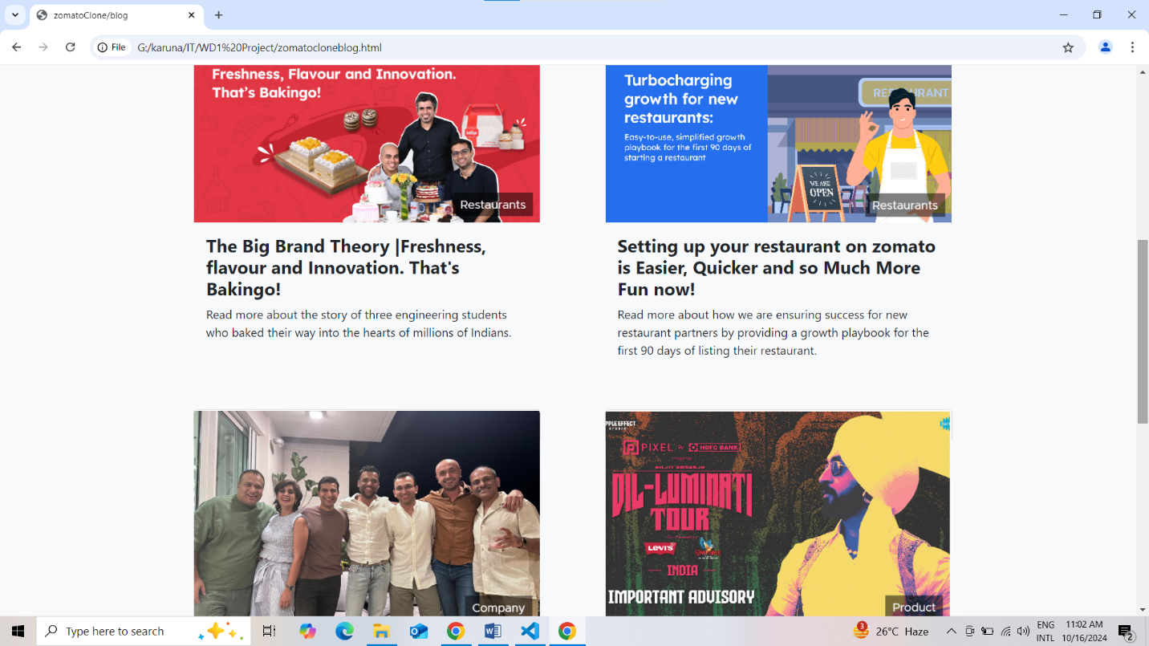

SITE MAP (FOOTER SECTION)

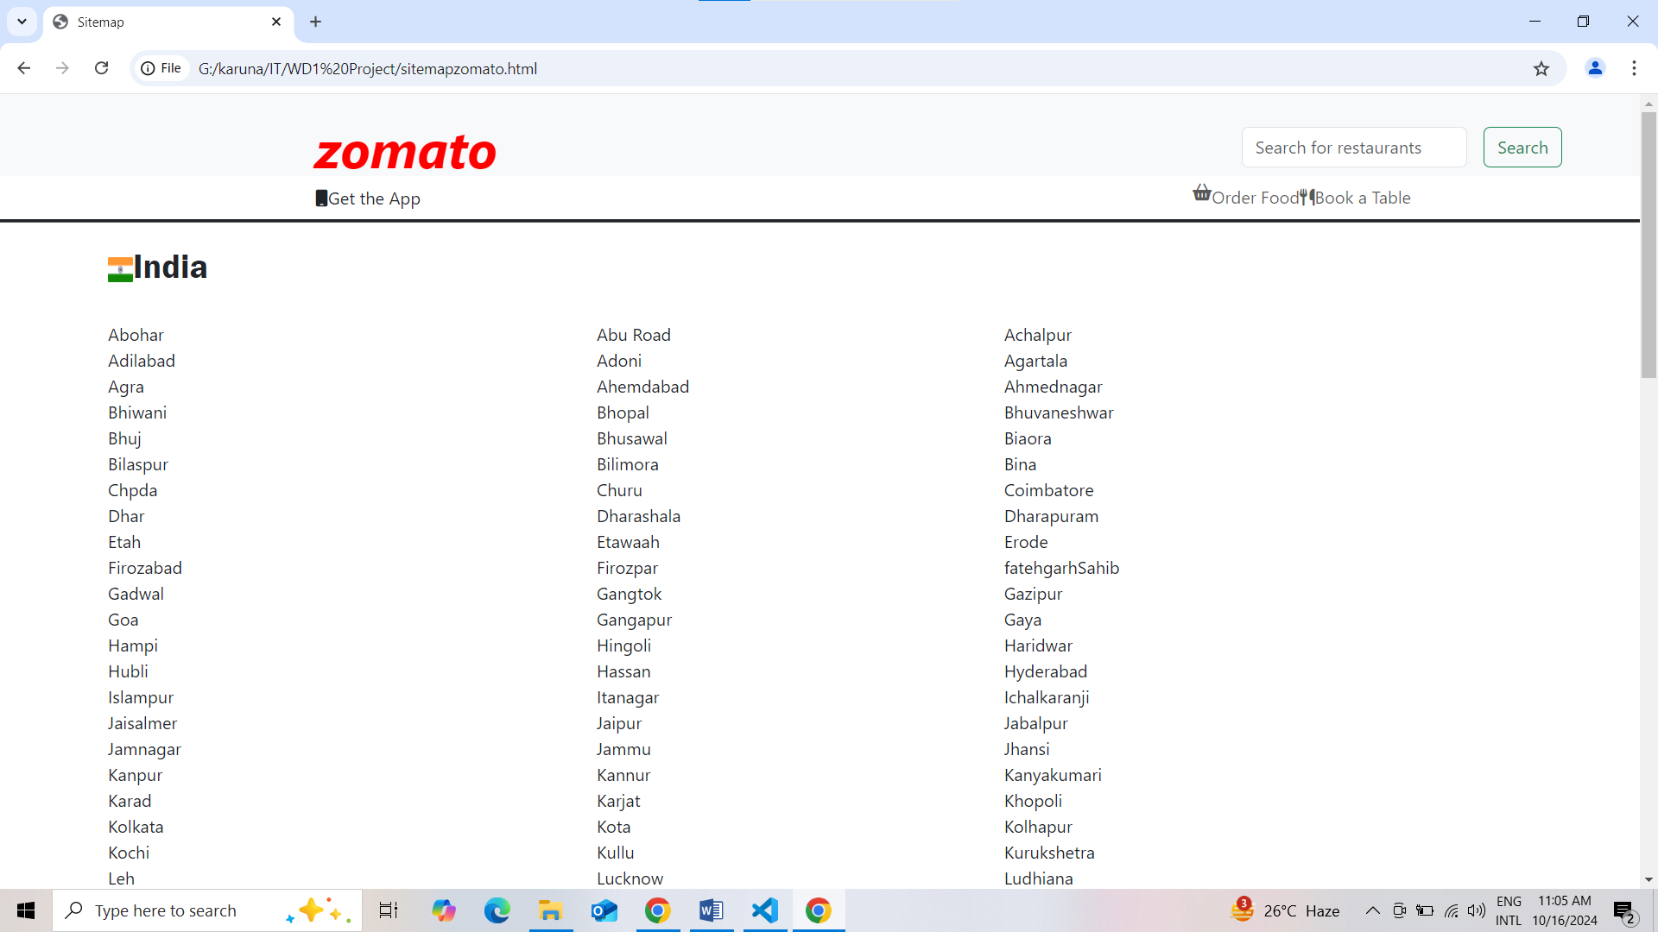

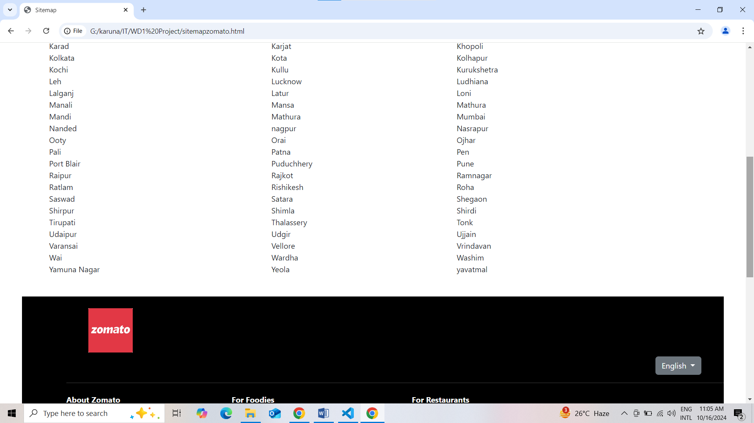

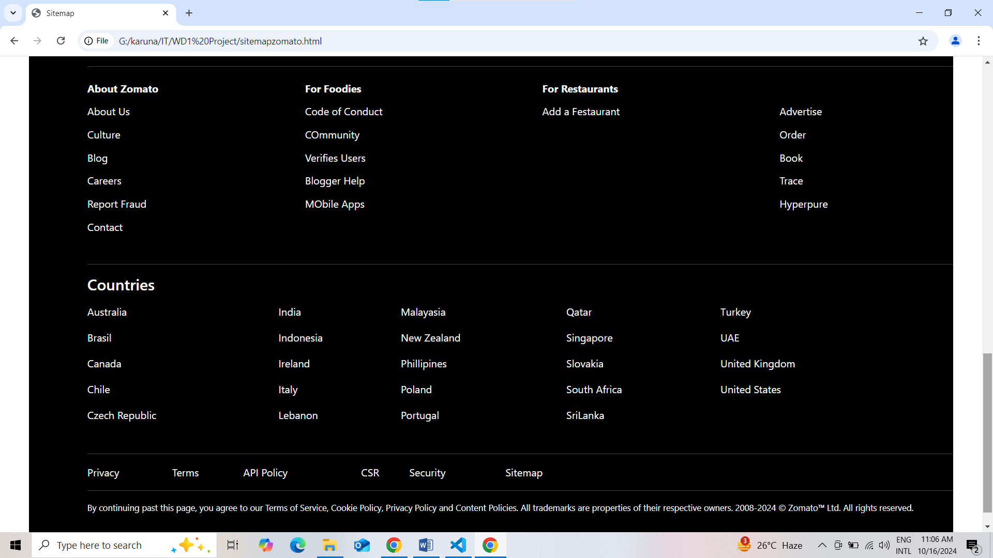

## 8. Future Improvements

* **Backend Integration**: To implement actual data fetching for restaurants and events.
* **User Authentication**: Adding a secure login and signup feature for user accounts.
* **Enhanced Search Functionality**: Incorporating filters and sorting options for better user experience.
* **Mobile App Development**: Extending the platform to mobile apps for iOS and Android.

## 9. Conclusion

The Zomatoclone project successfully replicates the essence of a food discovery platform, providing users with an engaging experience. Through continuous improvements and feature enhancements, it has the potential to evolve into a fully functional application that meets user needs in food discovery and delivery.